**DRUPAL ASSIGNMENT 3**

**Q1:- :Create a content type named Employee with following fields:**

**Employee name**

**Employee Description**

**Employee ID**

**Picture**

**Salary**

**Skills**

**Competency(taxonomy term)**

**Ans:-**

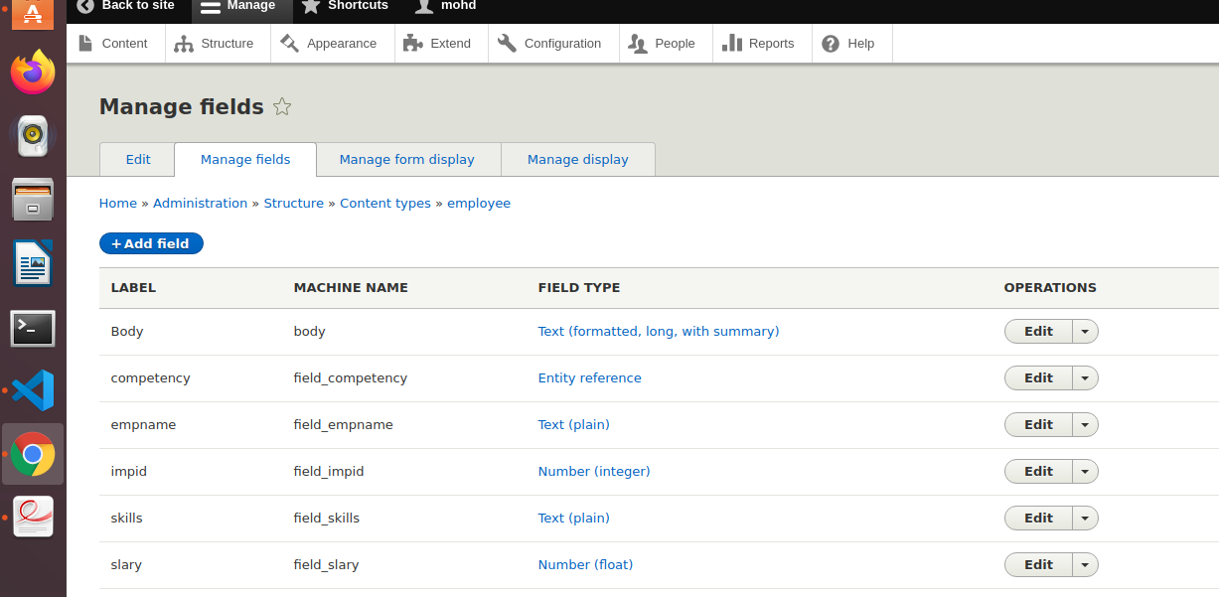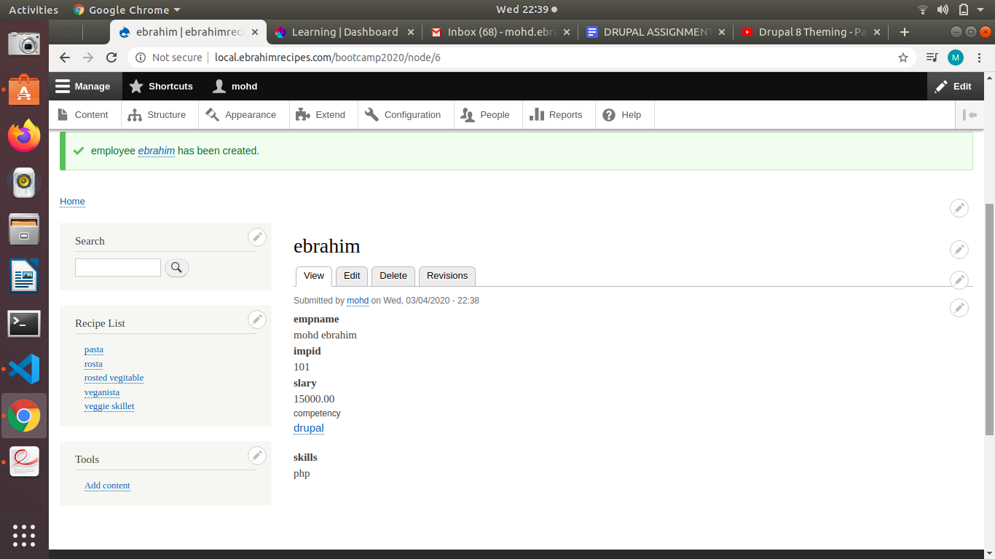

**Q2.Create a block programmatically listing all employee names and Employee IDs.**

**Ans:-**

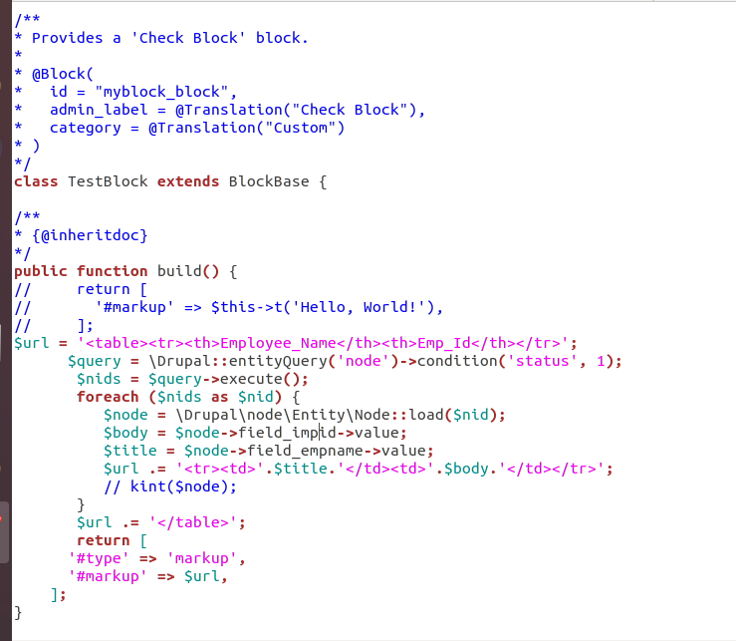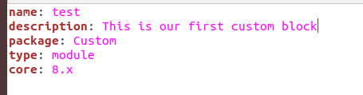

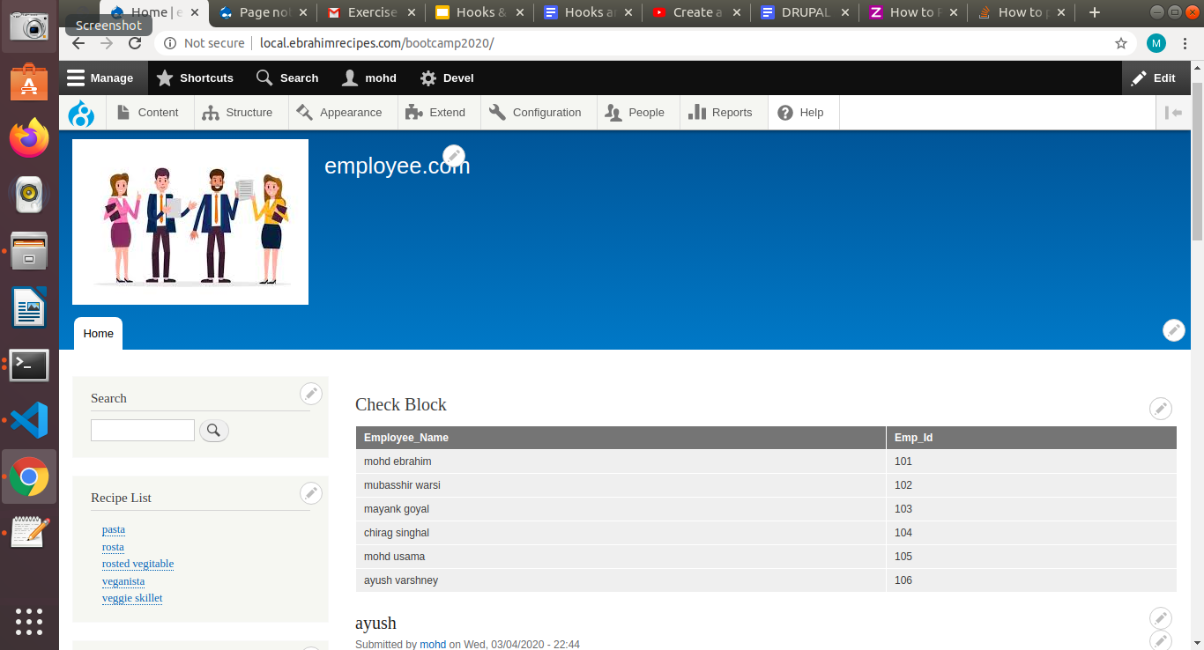

**Q3:- Create a view block of employee content type showing employee name and competency in grid format with 3 columns and group them on the basis of competency.**

**Ans:-** go to structure->view->add view and create new view

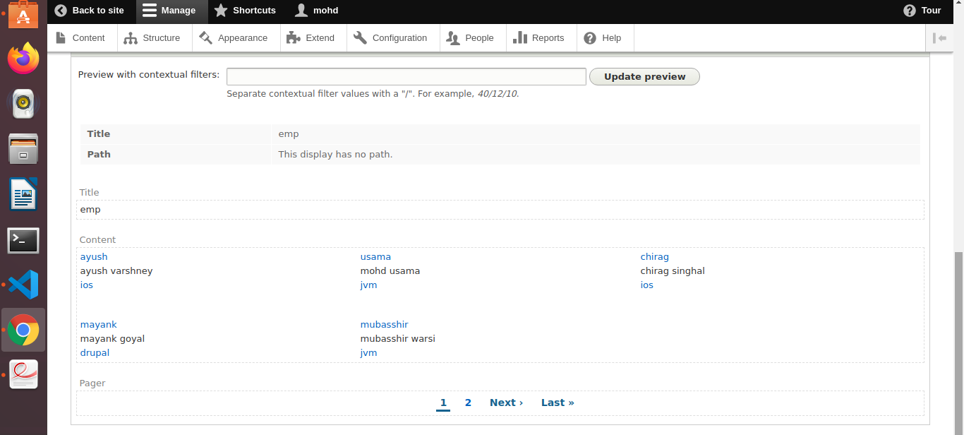

**Q5:Create a view page of employee content type in a table format with Employee name,**

**Employee ID and salary as header**

**1. Sort it on the basis of Employee ID**

**2. Trim the Employee Description field to 50 characters.**

**3. Add header “Total Records found : total”**

**4. Expose the filter for employee name**

**5. Expose the filter for employee id (use Between)**

**Ans:-**

**1. Sort it on the basis of Employee ID**

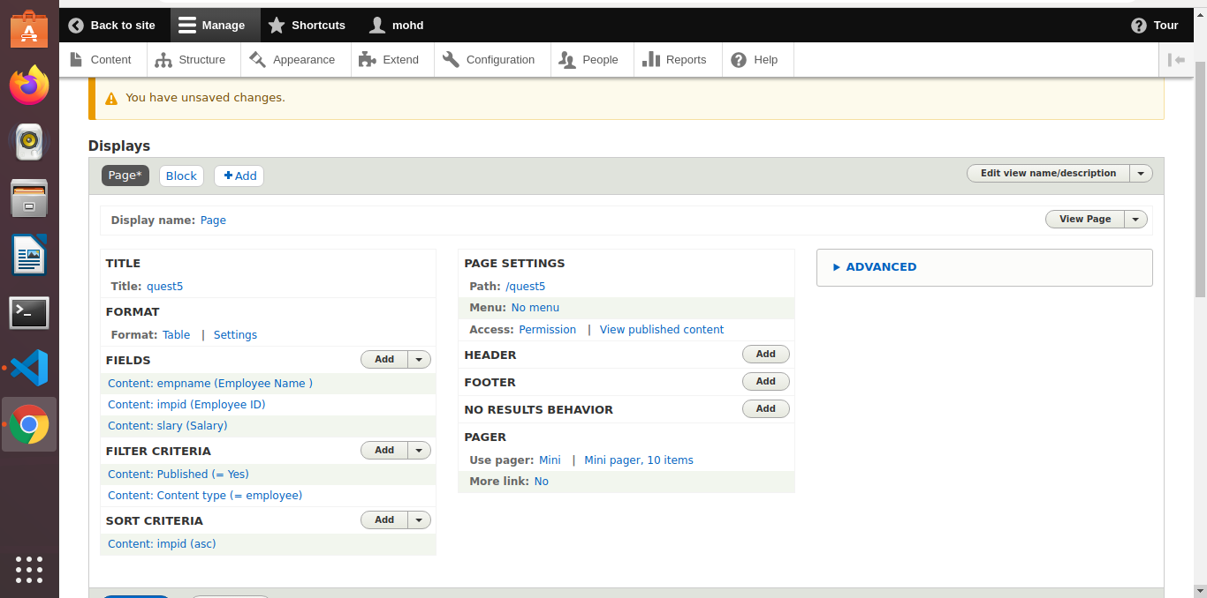

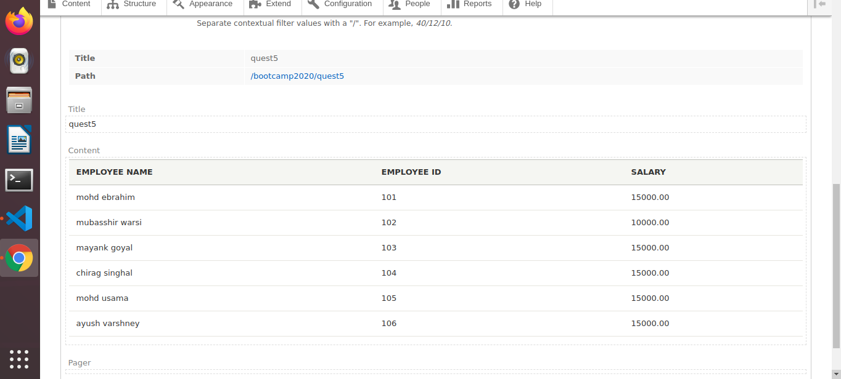

**2. Trim the Employee Description field to 50 characters.**

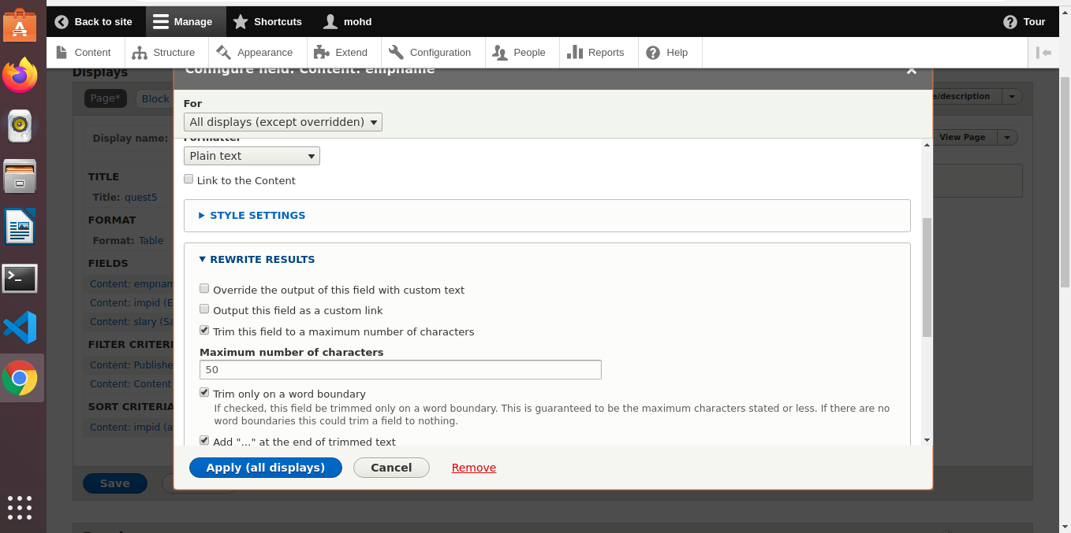

**Add header “Total Records found : total”**

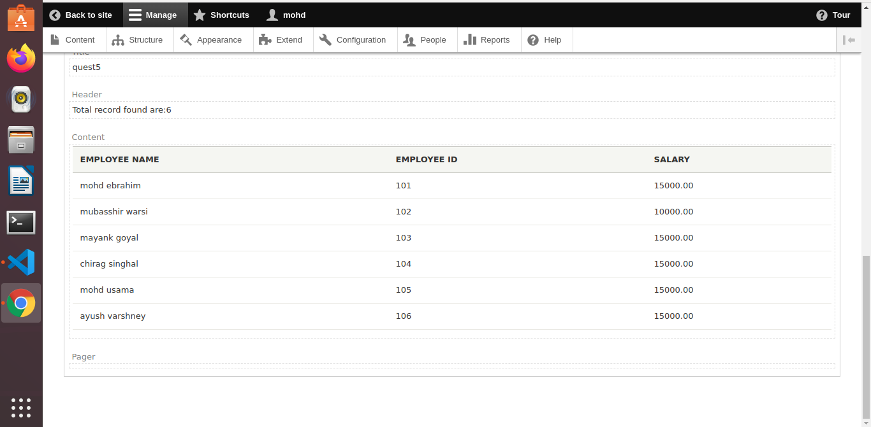

**4. Expose the filter for employee name**

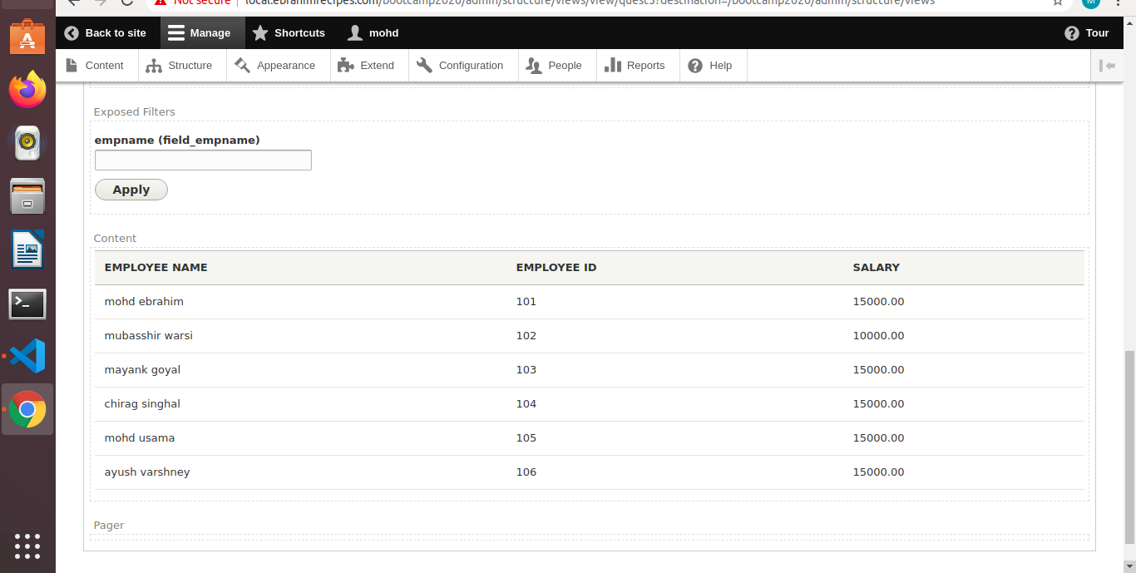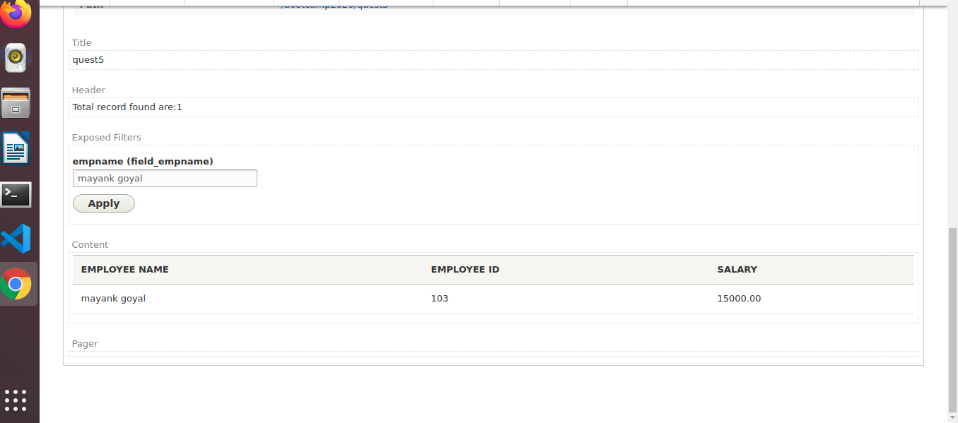

**Expose the filter for employee id (use Between)**

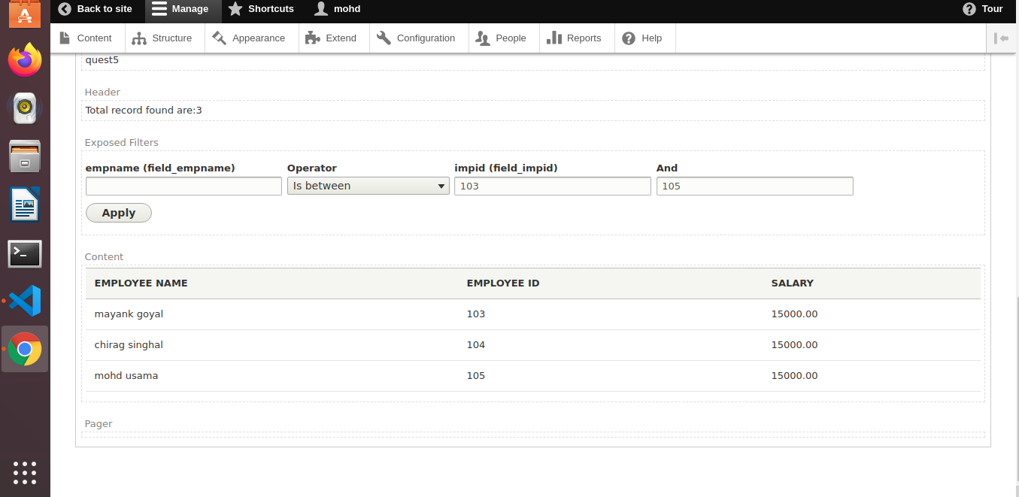

**Q6:- Create a view to show the Employee details(name,id) in HTML List on the basis of competency(taxonomy term id)**

**Ans:-** 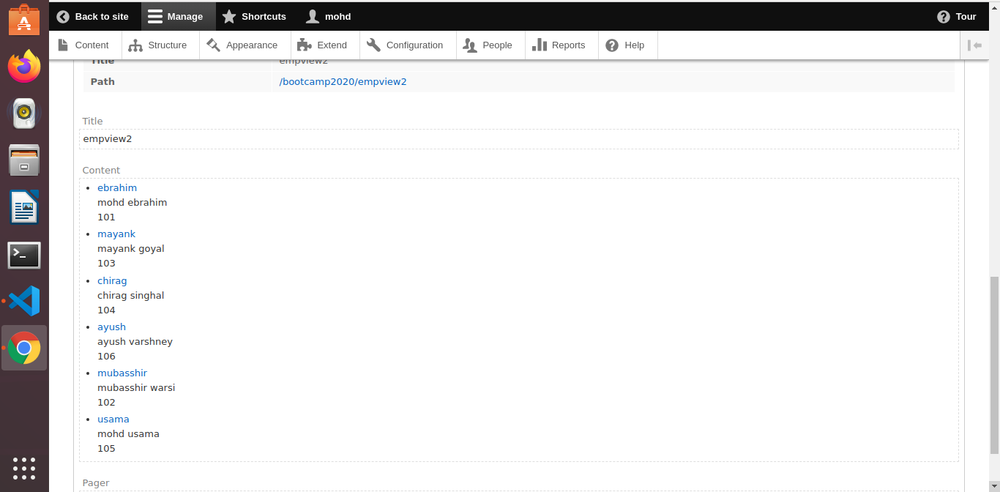

**Q7:-Create a view listing Employee name based on node id and show it on employee content type.**

**Note: The title(employee name) should be excluded in which the view is placed.**

**Ans:-** 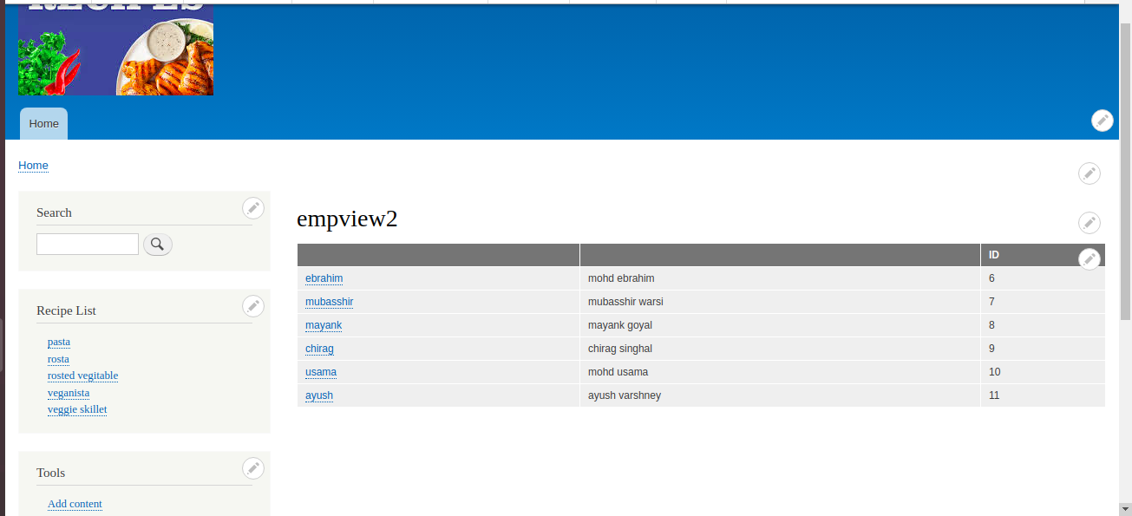

**Q8. Create a form with name and mobile fields and on submit show the field values entered inside a block programmatically.**

**Note: Last four question carry 3 marks and rest are of 2 marks each**

**Ans:-**

